**Action Return Types**

Following return types:

1. Specific Type
2. IActionResult
3. ActionResult<T>

Step 1: Add a “Employee” class in Models folder.

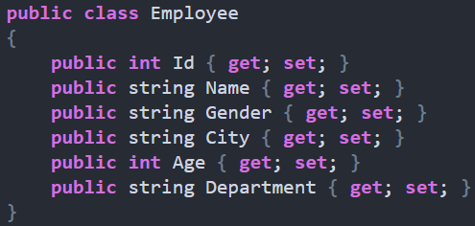

*Specific return type:*

Like int, bool, string, decimal etc.

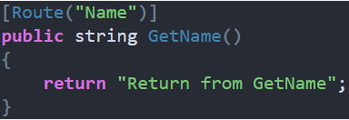

*Complex return type:*

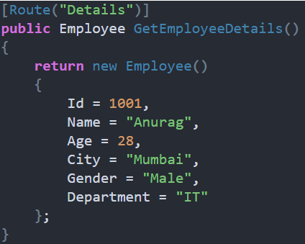

*List<T> return type:*

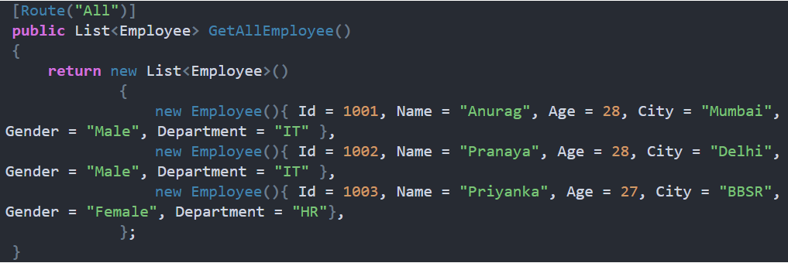

*IActionResult return type:*

1. It allows to return multiple types of data along with the status code, this is important for RESTful API.

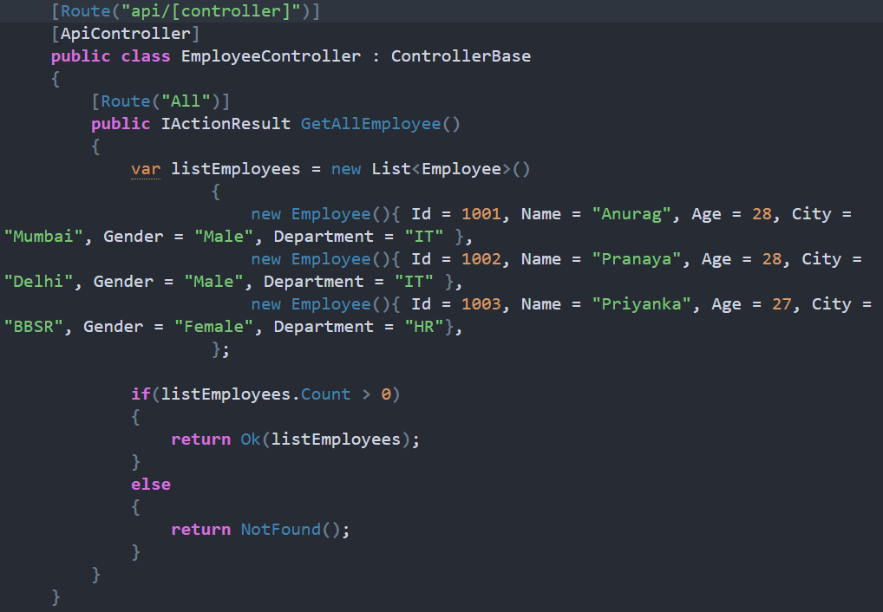

1. Drawback: as it returns multiple types of data, “Swagger” would not be able to identity the output, we need to use “ProducesResponseType” explicitly.

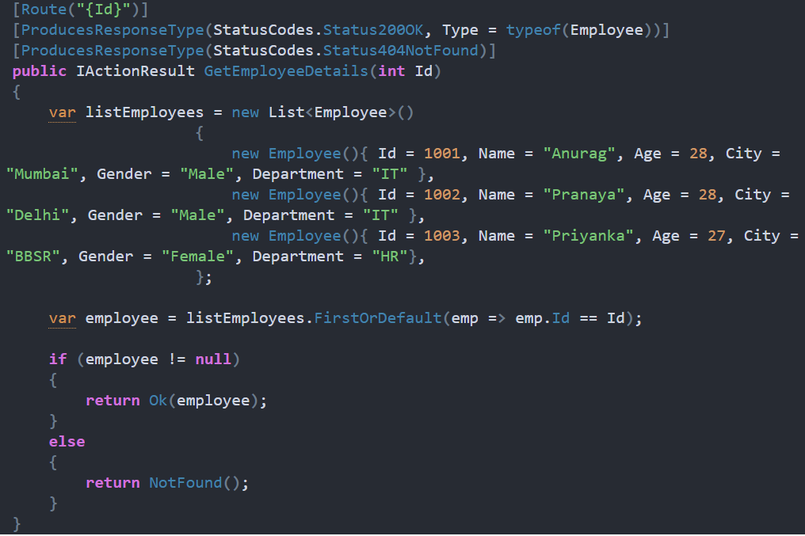

**ActionResult<T>**

1. It is introduced in Core 2.1.
2. It is the combination of ActionResult and Specific return type.

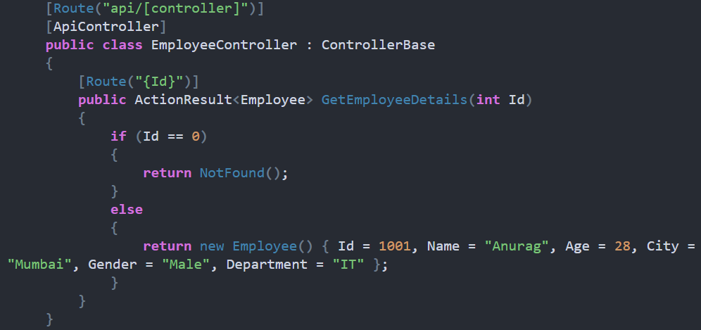

*Advantage of ActionResult<T> over ActionResult:*

1. The [ProducesResponseType] attribute’s Type property is not required.
2. Implicit cast operators support the conversion of both T and ActionResult to ActionResult<T>. T converts to ObjectResult, which means return new ObjectResult(T); is simplified to return T.